
293
Broker Opinion of Value
Date: May 09, 2026
Steele Oral Surgery

225 TX-121 Coppell TX 75019
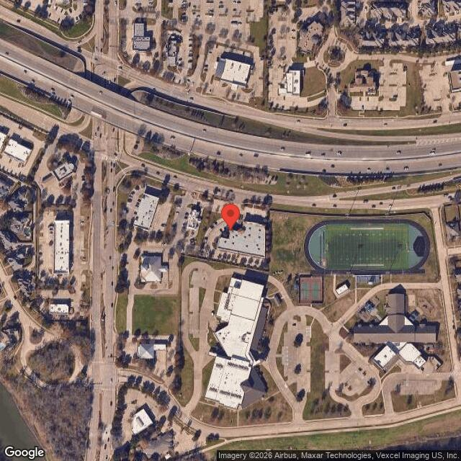
PREPARED FOR: Darrell Steele
Owner
225 TX-121 Coppell TX 75019
PREPARED BY: Braden Fisher
VASCRE
123 Example Address

Table of Contents

Executive Summary | ______________________________________________________ | 3
Subject Photos | ______________________________________________________ | 5
Demographics | ______________________________________________________ | 5
Comparables | ______________________________________________________ | 14
Certification | ______________________________________________________ | 21

EXECUTIVE SUMMARY
Broker Opinion of Value
Date: May 09, 2026
Steele Oral Surgery
An executive summary provides a concise overview of the report's key findings. It helps stakeholders—such as buyers, sellers, or investors—quickly understand the property’s estimated value and the reasoning behind it, enabling informed decision-making based on essential data and market trends.

PROPERTY SUMMARY
The property is located at 225 TX-121, Coppell, Texas, within Dallas County. It is part of the Dallas-Fort Worth-Arlington MSA, which is a major economic and cultural hub in Texas. The area is positioned in northern Texas, bordering Tarrant County to the west. This region is commonly referred to as the DFW Metroplex and is approximately 20 miles northwest of downtown Dallas, a significant financial center in the region. The broader North Texas area includes all of Dallas, Tarrant, Collin, and Denton counties. Dallas is the Dallas County seat of Dallas County.
SUMMARY OF STRENGTHS & WEAKNESSES OF SUBJECT ASSET
Market Sale Price | $265.00/PSF X 24,500 | $6,492,500
Market Sales Price (Rounded) |  | $6,490,000
SALE OPINION OF VALUE
Aggressive | Market Value | Conservative
$6,752,200 | $6,492,500 | $6,232,800

GENERAL INFORMATION
Property Name | Steele Oral Surgery
Property Type | Retail
State | Texas
County | United States
Longitude | -96.9914902
Latitude | 32.9849303
SITE INFORMATION
Level at street Grade | Level at street Grade
Shape | Irregular
Good | Good
Exposure | Average/Good
IMPROVEMENT INFORMATION
Lot Area | 24,500
Acres | 1.5
Recorded Sale Date | no data
Zoning | HC
APN | no data
Current Owner | Steele Oral Surgery

LOCATION SUMMARY
The subject property is located at 225 TX-121 in Coppell, Texas, offering excellent access and visibility due to its positioning along TX-121. This major thoroughfare provides partial frontage to the property, enhancing its exposure to significant vehicular traffic. Nearby amenities include Coppell High School, Andrew Brown Park, and a variety of retail and dining options, contributing to the area's appeal. The surrounding land uses primarily consist of residential neighborhoods and commercial developments, which support the property's retail designation. Dallas County, where the property is situated, is divided into distinct market areas, with Coppell falling within the competitive North Dallas submarket, known for its robust retail and commercial activity.

AERIAL MAP
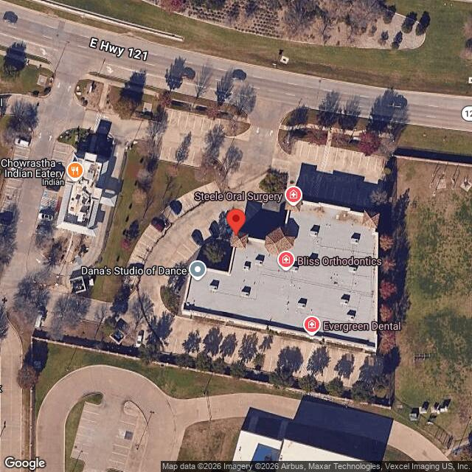

SUBJECT PHOTOS
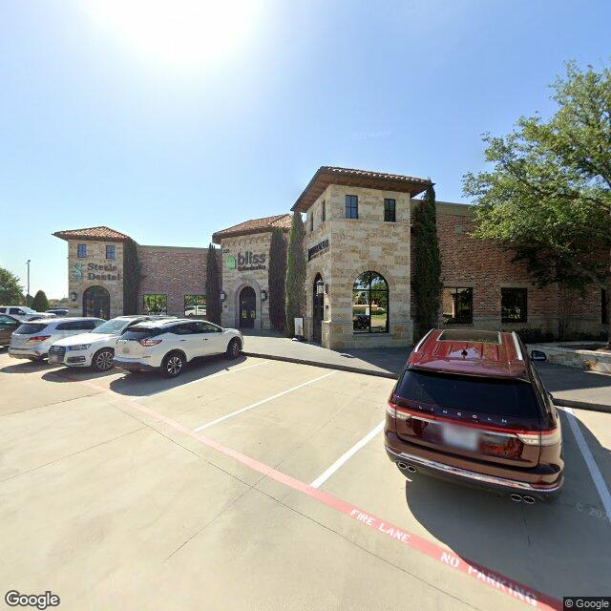
Broker Opinion of Value
Date: May 09, 2026
Steele Oral Surgery

REGIONAL ANALYSIS
An overview of the population and household characteristics in the area surrounding the subject property. Key indicators such as population growth, household income, age distribution, and employment trends are examined to illustrate the strength of the local market.

DEMOGRAPHIC ANALYSIS

Overview
The retail property at 225 TX-121 in Coppell, Texas, benefits from a robust demographic profile within Dallas County. The area is characterized by a growing population, with a significant number of young professionals and families, contributing to strong consumer demand. The median household income in the vicinity exceeds Texas and national averages, indicating a high purchasing power that supports retail activities. The proximity to major transportation routes enhances accessibility, attracting both local and transient shoppers. The demographic trends, including a projected population growth rate above 2% annually, suggest sustained demand for retail services, making this a strategically advantageous location for retail investment.

Size and Level at street Grade
The retail property located at 225 TX-121, Coppell, Texas, is situated on relatively flat terrain conducive to commercial development. The topography is characterized by minimal elevation changes, which simplifies construction planning and reduces potential grading costs. The site's level nature enhances its suitability for retail use, allowing for efficient layout and maximization of usable space. Additionally, the flat topography supports easy access for both vehicular and pedestrian traffic, which is critical for retail operations. Overall, the property's size and topography present it as an attractive option for developers seeking to capitalize on the retail market in Dallas County.

Population
Coppell, located in Dallas County, Texas, has experienced consistent population growth, driven by its strategic location and strong economic environment, positively impacting retail property demand at 225 TX-121.

POPULATION
YEAR | U.S. | STATE | COUNTY
2010 Total Population | 303,965,272 | 24,311,891 | 2,321,014
2020 Total Population | 324,697,795 | 28,260,856 | 2,606,868
2025 Total Population | 336,388,156 | 30,355,979 | 2,603,816
Source: US Census
POPULATION DENSITY
YEAR | U.S. | STATE | COUNTY
2020 Per Square Mile | 92 | 108 | 2,985
2025 Per Square Mile | 94 | 113 | 2,982
Source: US Census

Household Trends
The area surrounding 225 TX-121 in Coppell, Texas, exhibits a balanced owner/renter mix, with a slight majority of households owning their properties. This balance supports a stable consumer base for retail establishments, as homeowners often exhibit higher spending patterns. Household sizes in the region tend to average between three and four members, which indicates a significant presence of family units. This demographic trend is favorable for retail businesses that cater to family needs. Population growth in Dallas County, particularly in suburban areas like Coppell, continues to be robust, driven by economic Opportunity for future development and quality of life factors. This growth positively impacts the retail sector by expanding the potential customer base, enhancing business viability for properties like the one at 225 TX-121.

NUMBER OF HOUSEHOLDS
YEAR | U.S. | STATE | COUNTY
2024 Households | 129,267,625 | 11,026,668 | 982,378
2029 Households | 138,573,295 | 12,536,638 | 1,037,611
CAGR | 1.4% | 2.6% | 1.1%
Source: US Census
AVERAGE HOUSEHOLD SIZE
YEAR | U.S. | STATE | COUNTY
2024 | 2.52 | 2.66 | 2.62
2029 | 2.42 | 2.50 | 2.46
2024-2029 CAGR | -0.8% | -1.3% | -1.2%
Source: US Census
The area surrounding 225 TX-121 in Coppell, Texas, exhibits a balanced owner/renter mix, with a slight majority of households owning their properties. This balance supports a stable consumer base for retail establishments, as homeowners often exhibit higher spending patterns. Household sizes in the region tend to average between three and four members, which indicates a significant presence of family units. This demographic trend is favorable for retail businesses that cater to family needs. Population growth in Dallas County, particularly in suburban areas like Coppell, continues to be robust, driven by economic Opportunity for future development and quality of life factors. This growth positively impacts the retail sector by expanding the potential customer base, enhancing business viability for properties like the one at 225 TX-121.
HOUSING UNITS
 | U.S. | STATE | COUNTY
Owner Occupied | 65.0% | 62.6% | 50.8%
Renter Occupied | 35.0% | 37.4% | 49.2%
Source: US Census
The retail property at 225 TX-121 in Coppell, Texas, benefits significantly from its strategic location in Dallas County, a rapidly growing region with robust economic activity. Situated near major highways, the property provides excellent accessibility to both local consumers and businesses, enhancing its attractiveness to retailers. Dallas County's diversified economy, featuring sectors such as technology, finance, and healthcare, contributes to a stable job market and increasing consumer spending power. This economic diversity mitigates risks associated with sector-specific downturns, supporting sustained demand for retail spaces. Additionally, the area's population growth and rising median incomes further bolster the property's potential for long-term value appreciation. The combination of these factors positions the property favorably within the competitive retail landscape of the Dallas-Fort Worth metropolitan area.
Local Area Analysis
LOCAL AREA DEMOGRAPHICS
Description | 1 mile | 3 miles | 5 miles |  | Description | 1 mile | 3 miles | 5 miles
Population |  |  |  |  | Average Household Income
2010 Population | 11,800 | 78,293 | 179,087 |  | 2024 | $190,784 | $140,172 | $140,601
2020 Population | 13,538 | 92,721 | 210,359 |  | 2029 | $188,789 | $141,015 | $143,364
2024 Population | 13,236 | 95,135 | 218,467 |  | Change 2024-2029 | -1.0% | 0.6% | 2.0%
2029 Population | 13,097 | 95,705 | 222,727 |  | Median Household Income
Change 2010-2020 | 14.7% | 18.4% | 17.5% |  | 2024 | $155,826 | $99,250 | $103,471
Change 2020-2024 | -2.2% | 2.6% | 3.9% |  | 2029 | $154,196 | $99,846 | $105,504
Change 2024-2029 | -1.1% | 0.6% | 1.9% |  | Change 2024-2029 | -1.0% | 0.6% | 2.0%
Number of Households |  |  |  |  | Per Capita Income
2010 Households | 4,286 | 31,505 | 69,307 |  | 2024 | $69,466 | $58,348 | $55,730
2020 Households | 928,341 | 928,341 | 928,341 |  | 2029 | $68,739 | $58,698 | $56,825
2024 Households | 4,659 | 39,580 | 86,439 |  | Change 2024-2029 | -1.0% | 0.6% | 2.0%
2029 Households | 4,799 | 42,940 | 93,534 |  | Households by Income (2022)
Change 2010-2020 | 1.1% | 1.1% | 1.1% |  | Less than $15,000 | 78,406 | 78,406 | 78,406
Change 2020-2024 | 1.1% | 1.1% | 1.1% |  | $15,000 - $24,999 | 58,193 | 58,193 | 58,193
Change 2024-2029 | 3.0% | 8.5% | 8.2% |  | $25,000 - $34,999 | 65,443 | 65,443 | 65,443
Housing Units |  |  |  |  | $35,000 - $49,999 | 113,751 | 113,751 | 113,751
Owner Occupied | 60.5% | 41.7% | 46.1% |  | $50,000 - $74,999 | 175,144 | 175,144 | 175,144
Renter Occupied | 39.5% | 58.3% | 53.9% |  | $75,000 - $99,999 | 128,749 | 128,749 | 128,749
Housing Units by Year Built |  |  |  |  | $100,000 - $149,999 | 162,178 | 162,178 | 162,178
Built 2020 or Later | 14,043 | 14,043 | 14,043 |  | $150,000 - $199,999 | 78,143 | 78,143 | 78,143
Built 2010 to 2019 | 121,755 | 129,654 | 129,654 |  | $200,000 or More | 111,683 | 111,683 | 111,683
Built 2000 to 2009 | 129,654 | 129,654 | 129,654 |  | Housing by Units in Structure
Built 1990 to 1999 | 120,269 | 120,269 | 120,269 |  | 1, Detached | 548,642 | 548,642 | 548,642
Built 1980 to 1989 | 184,099 | 184,099 | 184,099 |  | 1, Attached | 40,018 | 40,018 | 40,018
Built 1970 to 1979 | 169,987 | 169,987 | 169,987 |  | 2 | 13,890 | 13,890 | 13,890
Built 1960 to 1969 | 129,214 | 129,214 | 129,214 |  | 3 or 4 | 47,617 | 47,617 | 47,617
Built 1950 to 1959 | 113,626 | 113,626 | 113,626 |  | 5 to 9 | 72,524 | 72,524 | 72,524
Built 1940 to 1949 | 34,161 | 34,161 | 34,161 |  | 10 to 19 | 96,128 | 96,128 | 96,128
Built 1939 or Earlier | 36,663 | 36,663 | 36,663 |  | 20 to 49 | 68,327 | 68,327 | 68,327
Home Values |  |  |  |  | 50 or More | 148,582 | 148,582 | 148,582
Average | $577,622 | $537,551 | $508,186 |  | Mobile Home | 17,521 | 17,521 | 17,521
Median | $551,178 | $486,662 | $459,236 |  | Boat, RV, Van, etc. | 222 | 222 | 222
Source: Esri

EMPLOYMENT
Coppell, Texas, located in Dallas County, benefits from a robust labor market, which is essential for supporting retail properties like the one at 225 TX-121. The area has experienced steady employment growth, driven by the technology, finance, and logistics sectors, which are significant employers in the region. This growth positively influences retail demand, as increased employment enhances consumer spending power. The unemployment rate in Dallas County remains below the national average, reflecting a healthy economic environment conducive to retail success. As industries continue to expand, particularly those investing heavily in technology and innovation, the demand for retail spaces is likely to remain strong. The presence of major corporate offices nearby further supports the labor market, providing a stable customer base for retail businesses. Overall, the local employment landscape presents favorable conditions for retail property investment, driven by diverse industries and a growing workforce.
EMPLOYMENT & UNEMPLOYMENT STATISTICS 2010 – 2019
 | TOTAL EMPLOYMENT |  |  |  |  |  | UNEMPLOYMENT RATE
Texas |  |  | Dallas County, TX |  | United States |  | Texas | Dallas County, TX
Year | Total | % ∆ Yr Ago | Total | % ∆ Yr Ago
2010 | 11,264,356 | no data | 1,093,403 | no data | 9.6% |  | 8.3% | 8.7%
2011 | 11,476,396 | 1.9% | 1,107,910 | 1.3% | 8.9% |  | 8.0% | 8.4%
2012 | 11,776,895 | 2.6% | 1,132,213 | 2.2% | 8.1% |  | 6.7% | 7.1%
2013 | 11,986,038 | 1.8% | 1,147,198 | 1.3% | 7.4% |  | 6.3% | 6.7%
2014 | 12,304,235 | 2.7% | 1,177,878 | 2.7% | 6.2% |  | 5.2% | 5.5%
2015 | 12,445,940 | 1.2% | 1,203,242 | 2.2% | 5.3% |  | 4.5% | 4.3%
2016 | 12,649,932 | 1.6% | 1,250,476 | 3.9% | 4.9% |  | 4.6% | 4.0%
2017 | 12,890,267 | 1.9% | 1,273,632 | 1.9% | 4.4% |  | 4.4% | 3.9%
2018 | 13,175,974 | 2.2% | 1,283,127 | 0.7% | 3.9% |  | 3.9% | 3.8%
2019 | 13,432,803 | 1.9% | 1,293,104 | 0.8% | 3.7% |  | 3.5% | 3.5%
CAGR | 2.0% | - | 1.9% | - | - |  |  | -
Source: BLS (Bureau of Labor Statistics)

Economic Factors
The retail property at 225 TX-121 in Coppell, Texas, benefits significantly from its strategic location in Dallas County, a rapidly growing region with robust economic activity. Situated near major highways, the property provides excellent accessibility to both local consumers and businesses, enhancing its attractiveness to retailers. Dallas County's diversified economy, featuring sectors such as technology, finance, and healthcare, contributes to a stable job market and increasing consumer spending power. This economic diversity mitigates risks associated with sector-specific downturns, supporting sustained demand for retail spaces. Additionally, the area's population growth and rising median incomes further bolster the property's potential for long-term value appreciation. The combination of these factors positions the property favorably within the competitive retail landscape of the Dallas-Fort Worth metropolitan area.

Community Services
The property at 225 TX-121 in Coppell, Texas, benefits from strong community services that enhance its retail potential. The area is well-served by parks, including Andrew Brown Park East and West, which provide recreational spaces that attract local families and increase foot traffic. Public safety is robust, with the Coppell Police Department maintaining a presence that contributes to a secure shopping environment. Healthcare access is facilitated by nearby facilities such as Baylor Scott & White Medical Center, ensuring that medical services are readily available to residents and visitors. Educational institutions, including Coppell High School and a range of elementary schools, contribute to a stable community with a steady influx of families. These community services collectively enhance the marketability and desirability of the retail property, supporting sustained tenant demand and potential rental growth.

MARKET ANALYSIS
Dallas County Retail Market Report – Q2 2026
Independent Analysis Based on Multiple Public Data Sources
1. Market Overview
Dallas County sits within the DFW retail market, which remains one of the tightest in the U.S. Overall retail vacancy in DFW measured approximately 4.8% in Q2 2025, with positive quarterly absorption and steady rent growth; Dallas County submarkets generally track the broader metro due to shared demand drivers and tenant pools. National brokerage outlooks note very low U.S. retail vacancy (~4.3%), limited new starts, and resilient tenant demand—context that aligns with local conditions.
2. Key Market Metrics
Vacancy Rates (Based on Public Data & Market Trends)
• Vacancy (DFW proxy): 4.8% (Q2 2025); metro vacancy edged down slightly as absorption turned positive. Dallas County submarkets typically move with metro trends given integrated retailer footprints.
• Asking Rents (DFW proxy): ~$24.90/SF market asking rent (Q2 2025), with ~4–5% annual growth. (Retail reporting is not commonly split into “Class A/B”; most sources publish overall asking rents.)
• Construction Pipeline (DFW): ~7.2 million SF under construction as of Q3 2025, the largest pipeline among U.S. metros; ~1.2M SF delivered in Q2.
• Investment Indicators (DFW): Average retail capitalization rate ~6.7% (Q2 2025).
Note: Reliable Dallas County-only breakouts for retail vacancy and asking rents are limited; DFW-level metrics are the accepted proxy in most public reports and closely reflect Dallas County performance.
Lease Rates (Based on Public Listings & Industry Trends)
Retail lease rates in Dallas County generally align with broader DFW metro trends, averaging around $25.50/SF as of Q2 2025. Annual rent growth has remained steady in the 3–4% range, supported by low vacancy and consistent retailer demand for well-located space. Infill strip centers and grocery-anchored properties continue to achieve premium rents, while older unanchored product often trades at a discount. National conditions also support stability, with U.S. retail vacancies near multi-decade lows and disciplined new supply. Overall, lease rates in Dallas County are expected to remain on a positive trajectory in the near term, particularly in high-traffic corridors and affluent trade areas.
Construction Activity
Construction activity in the DFW retail market remains elevated, with approximately 7.2 million SF under construction as of Q3 2025—the largest pipeline among U.S. metros. Within Dallas County, new projects are concentrated in infill redevelopment, grocery-anchored centers, and mixed-use corridors near population growth nodes. Deliveries in Q2 2025 totaled roughly 1.2 million SF, most of which was pre-leased or concentrated in strong submarkets, limiting direct impacts on vacancy. Developers remain disciplined, with construction levels well below prior peaks, helping sustain favorable supply-demand balance. In Coppell and surrounding submarkets, construction is modest compared to regional totals, underscoring the market’s stability and reliance on redevelopment over speculative building.
3. Trends & Forecast
• Demand skew to small shops: In 1H 2025, roughly two-thirds of new leases were 2,500 SF or smaller, and nearly 90% were 10,000 SF or smaller, reflecting service, food/beverage, and value retailers expanding into infill locations.
• Low new supply nationally supports rent growth: U.S. retail vacancies are holding near multi-decade lows (~4.3%), with construction starts down by about 50% year-over-year, supporting landlord leverage on well-located space.
• Local pipeline concentrated in growth corridors: DFW’s 7.2 million SF pipeline is focused around high-growth suburbs and grocery-anchored formats, with Dallas County benefiting from proximity and infill redevelopment.
4. Investment Insights
• Grocery-anchored and daily-needs strip centers remain the most liquid and resilient segments, supported by low vacancy and steady rent growth; recent cap rate averages are centered around 6.5–7.0%, with tighter yields for prime, grocery-anchored assets.
• Supply remains disciplined relative to history, but construction is picking up; underwriting should reflect rising replacement costs and selective rent growth concentrated in top trade areas.
5. Recommendations
• Prioritize infill, high-income trade areas and grocery-anchored centers with strong sales productivity and limited nearby new supply.
• Target small-shop re-tenanting Opportunity for future development (2–3k SF bays) where demand depth is strongest.
• For value-add, focus on lease-up of shop space and mark-to-market on below-market legacy rents in submarkets showing above-trend absorption.
6. Data Sources & Disclaimer
This analysis relies on multiple public sources:
• CoStar – Dallas Retail Market Q2 2023 (vacancy rates, rental rates, absorption)
• CBRE – Dallas-Fort Worth Retail MarketView Q3 2023 (demand, supply, construction)
• JLL – Texas Retail Outlook Q1 2023 (leasing activity, rent growth, investment sales)
• Cushman & Wakefield – Dallas-Fort Worth Retail Snapshot Q4 2023 (occupancy, new developments, leasing trends)
• Dallas Business Journal (September 2023) – Retail property investment and leasing trends in Dallas County
This report is based on publicly available data from multiple sources, including government property records, industry reports, and market analysis. While we have conducted an independent assessment, all figures should be verified with authoritative sources before making investment decisions. This document is for informational purposes only and should not be considered financial or investment advice.

PROPERTY COMPARABLES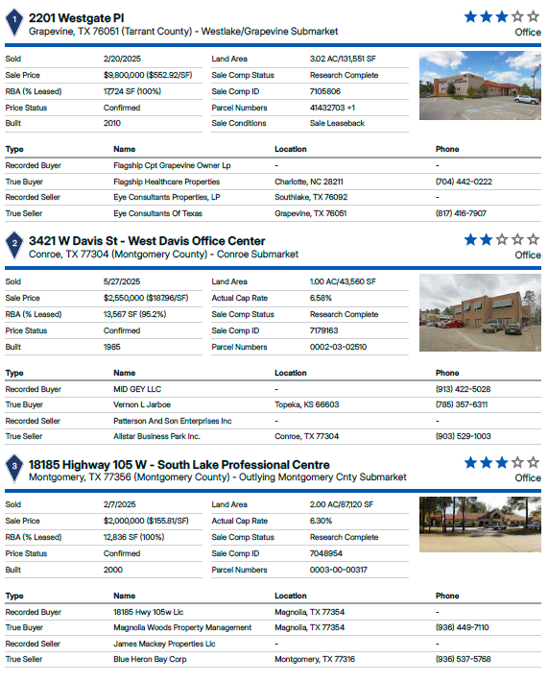
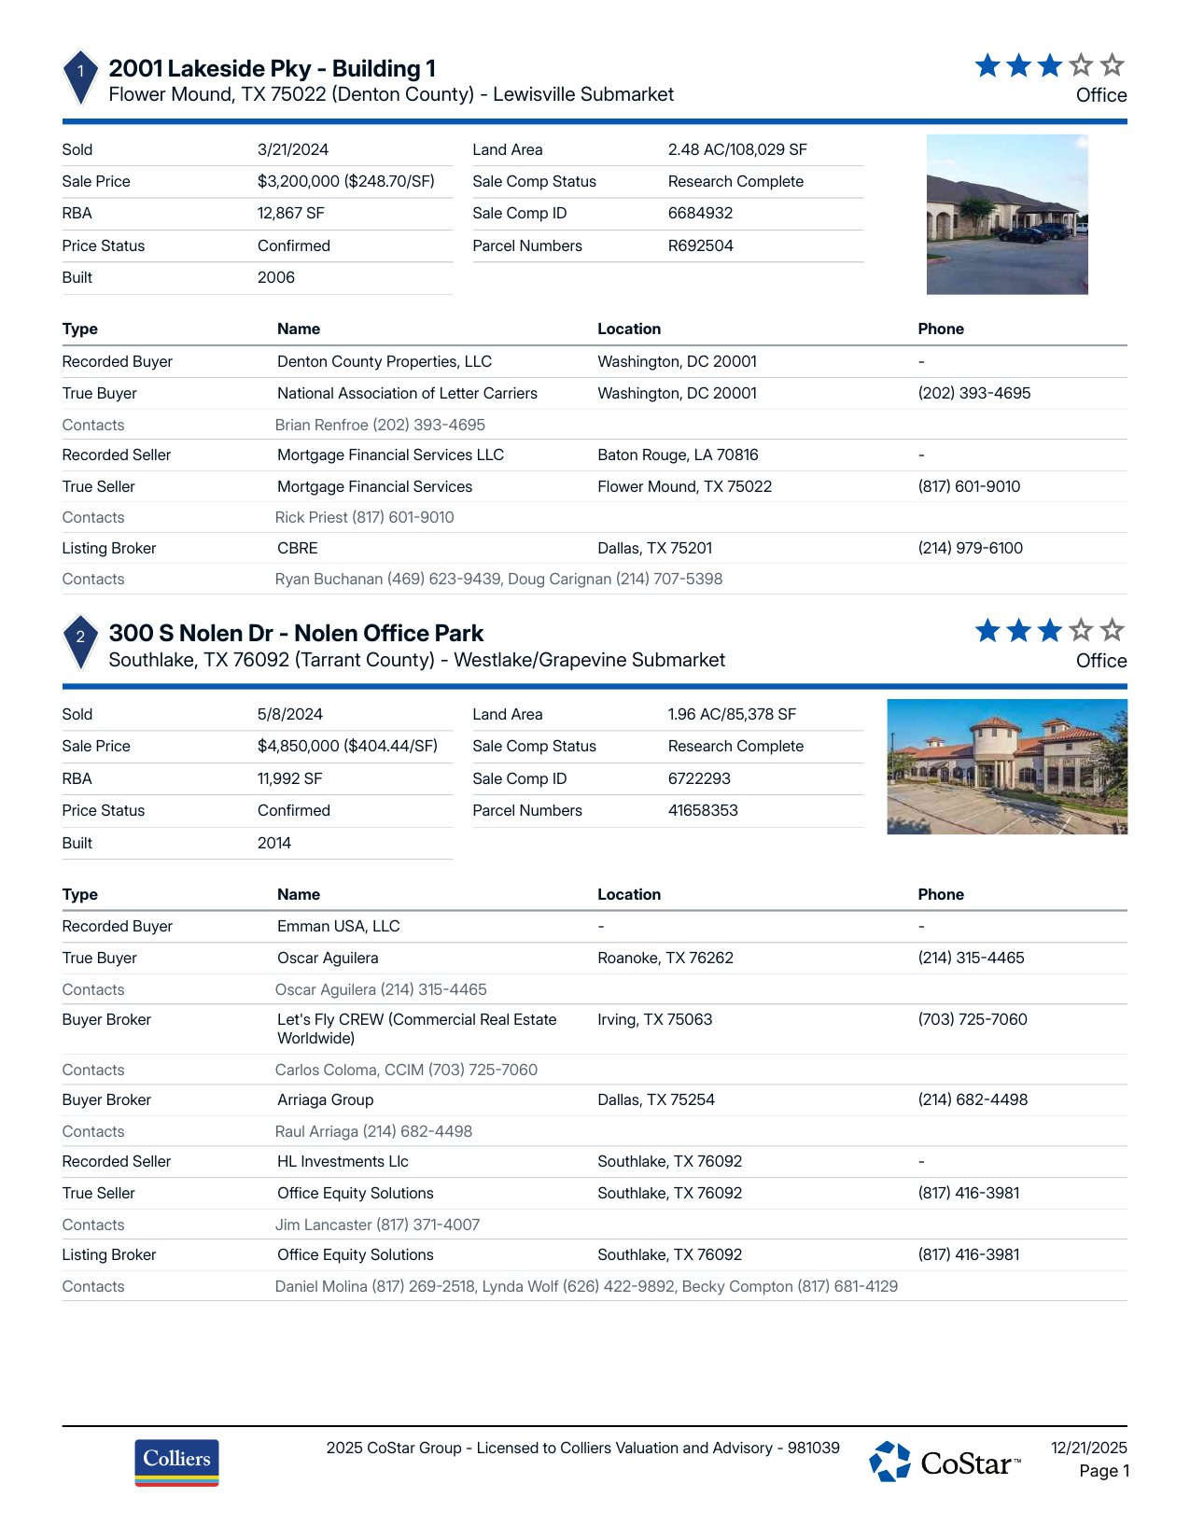
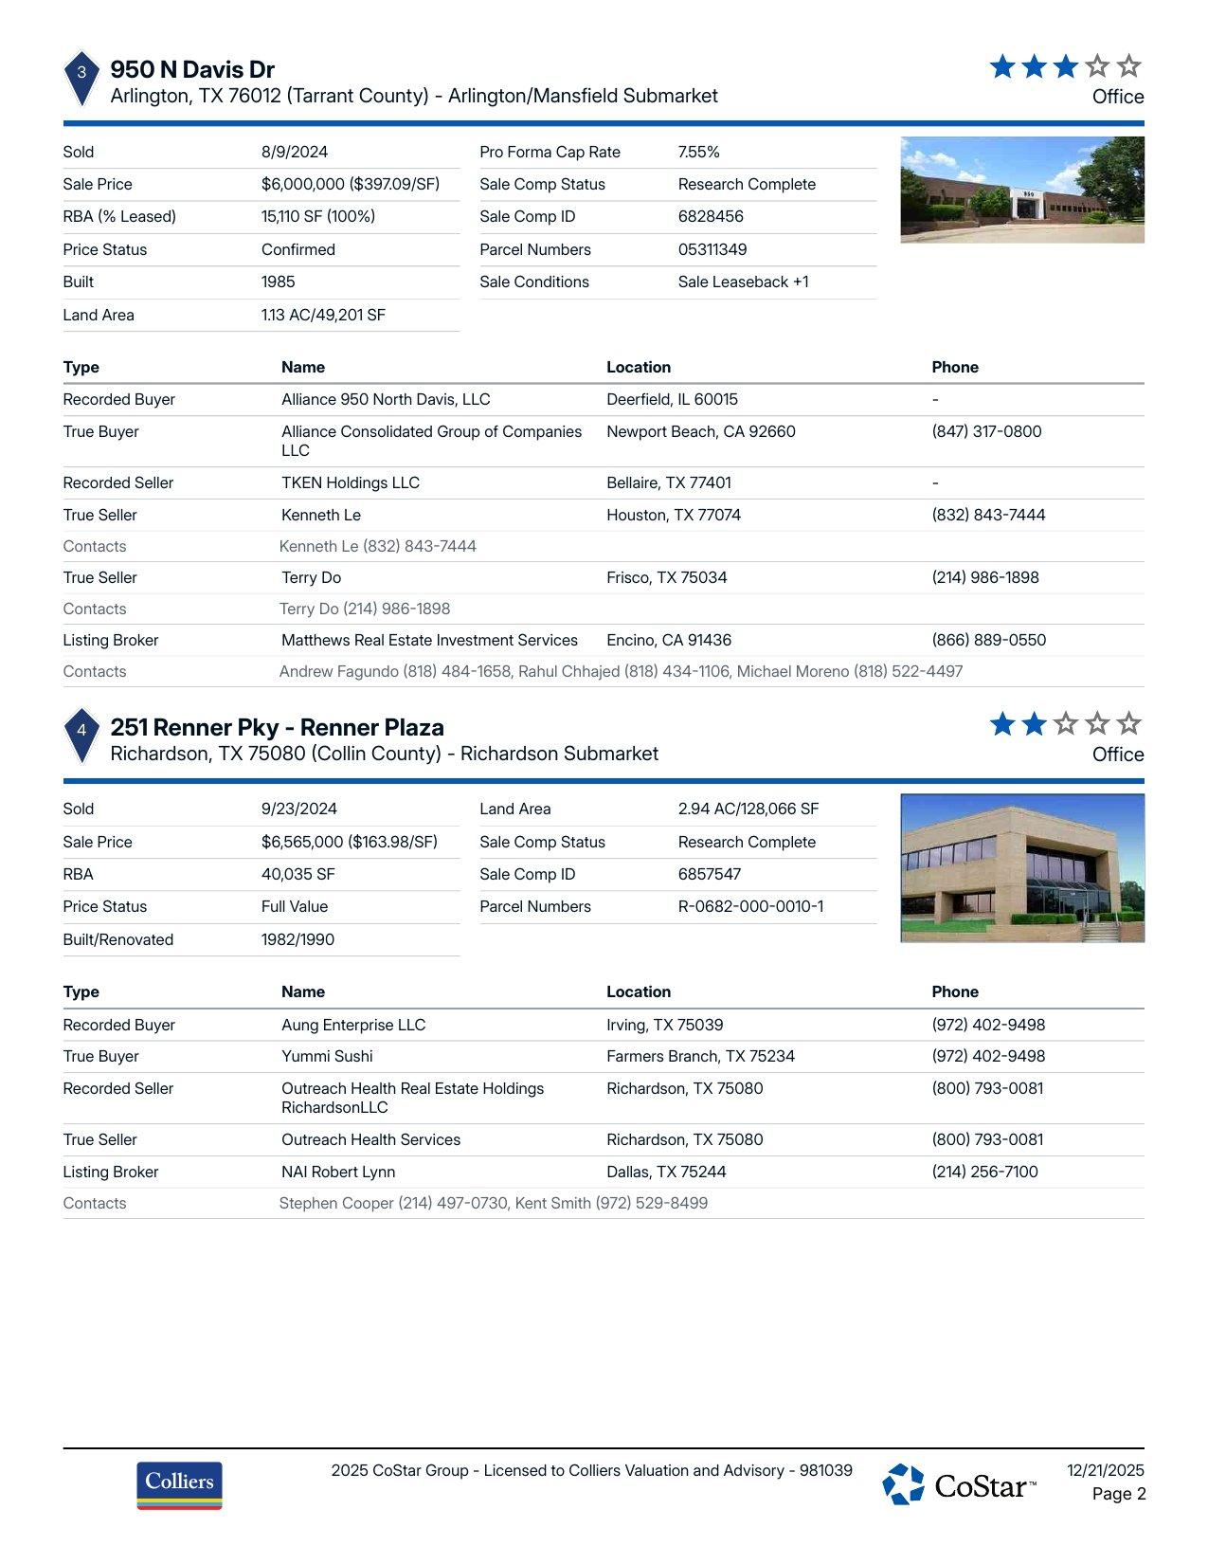
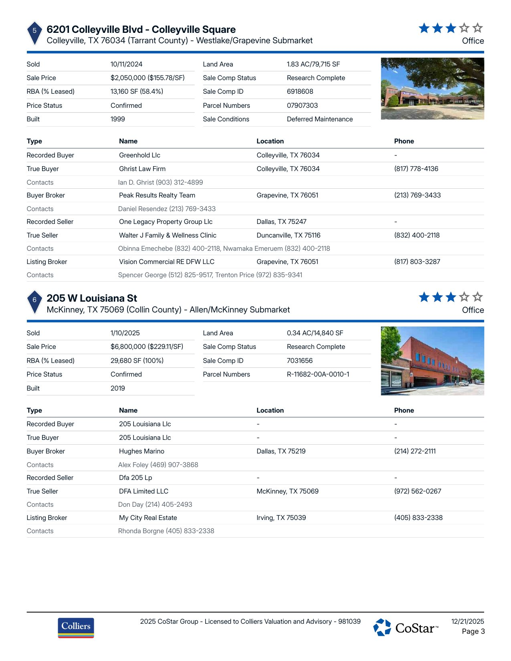
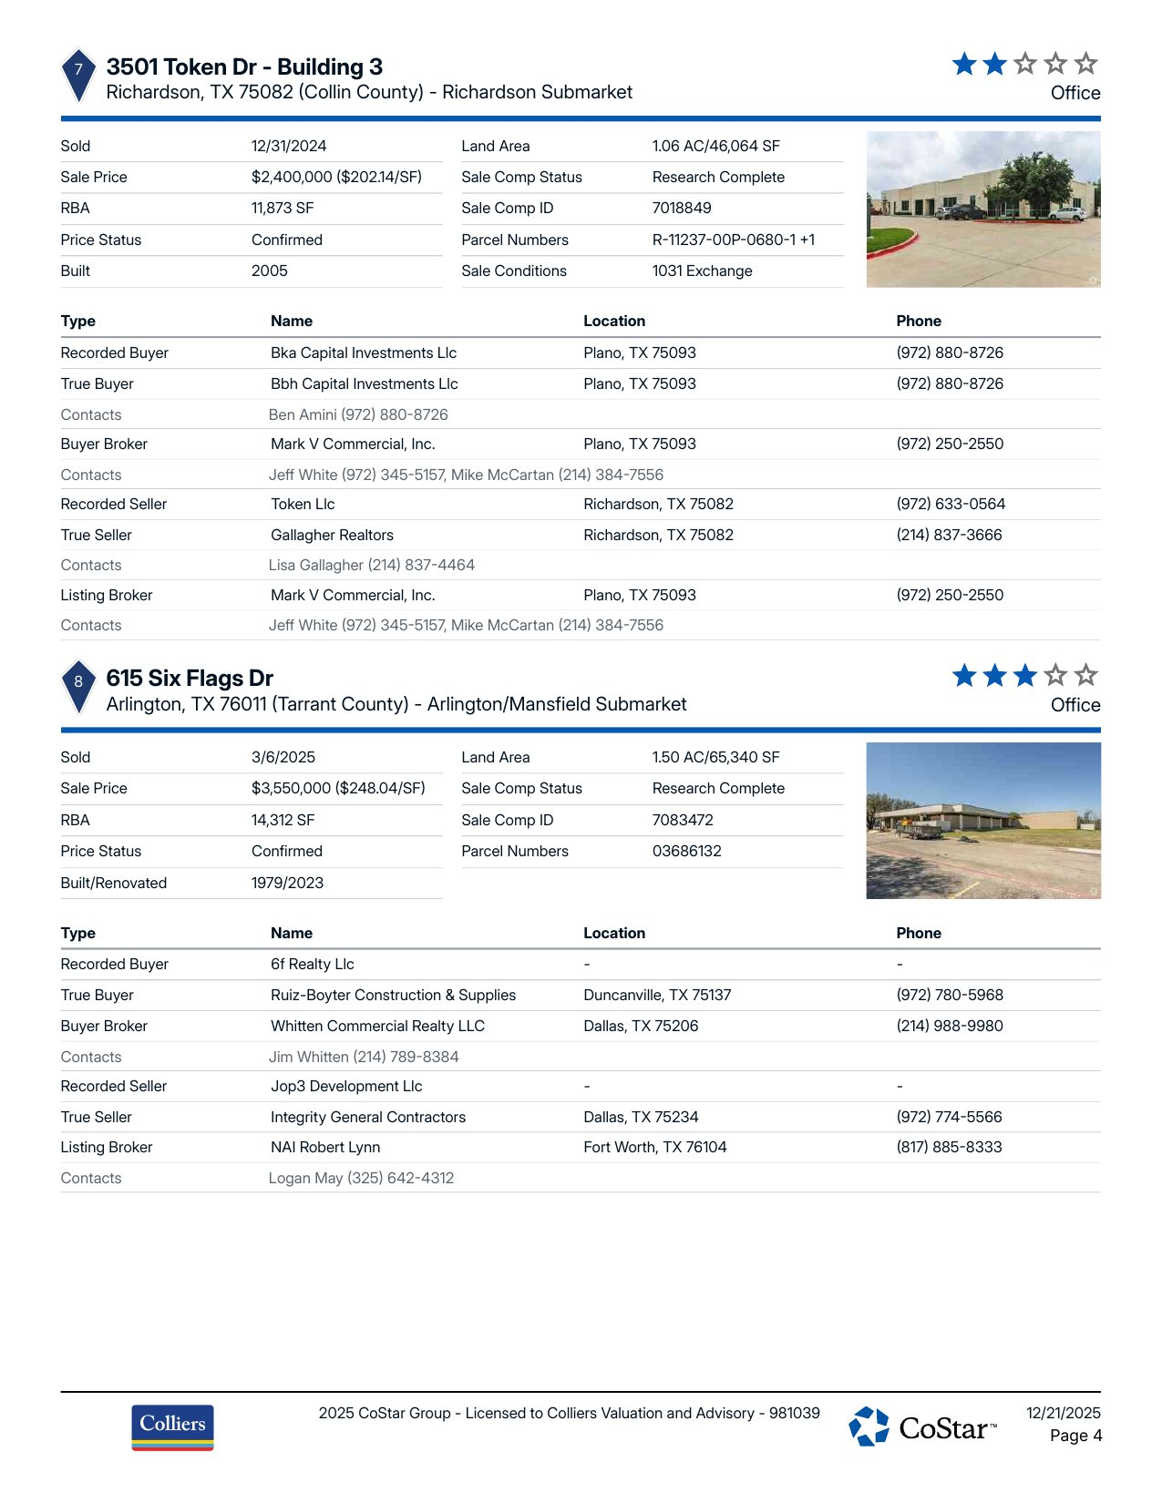
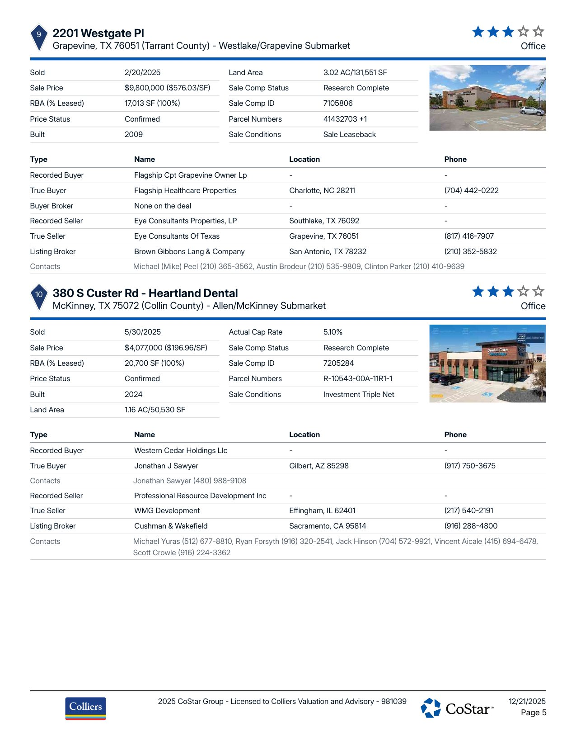
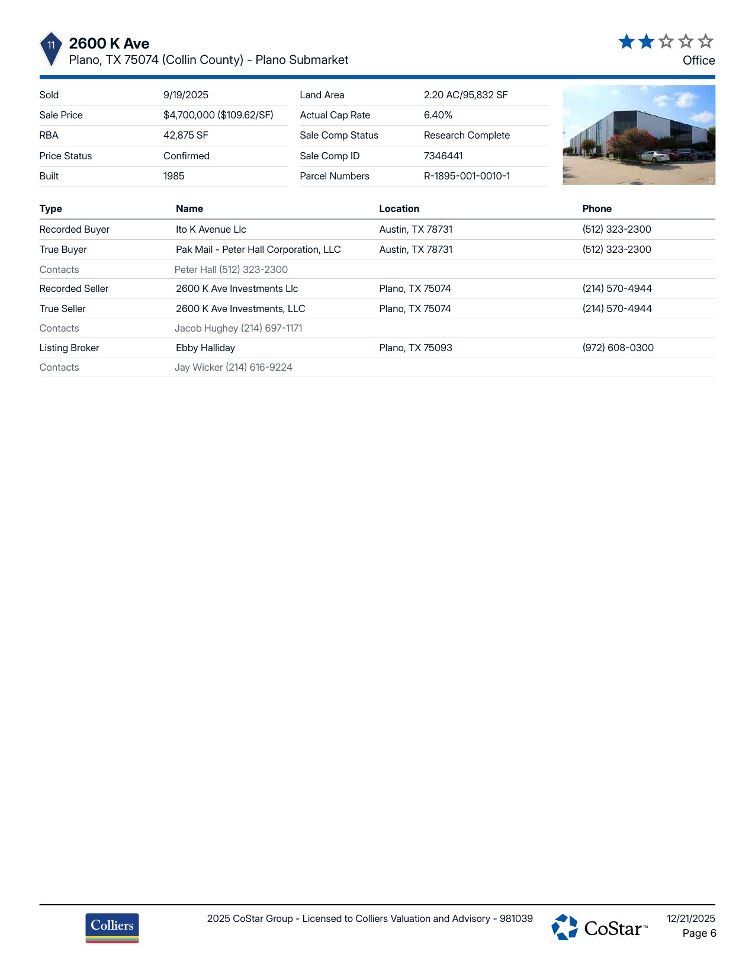

RECONCILIATION TABLE
The sales comparables analyzed for the subject property reflect a range in price from approximately $109.62/SF to $576.03/SF, with most transactions clustering between $163.98/SF and $248.70/SF. The highest-priced sale at $576.03/SF is attributed to newer construction, stronger tenancy, and a superior location. Conversely, the lowest-priced sale at $109.62/SF is due to its age, condition, and possibly deferred maintenance. Primary weight is placed on the mid-range indicators, which provide a balanced perspective of the market conditions. Based on this analysis, the concluded opinion of value for the subject is $6,490,000, supported by the market-average $266.54/SF applied to the subject's 24,500 SF.

VALUATION METHOD | VALUE ESTIMATE | NOTES
Sales Comparison Approach | $6,490,000 | The sales comparison approach yields a value of $6,490,000 based on the average $/SF from 11 comparables.

SALES CONCLUSION
OPINIONS OF VALUE
Market Sale Price | $265.00 SF | X | 24,500 | $6,492,500
Market Sales Price (Rounded) |  |  |  | $6,490,000

CERTIFICATION AND DISCLAIMERS
This Broker Opinion of Value (BOV) has been prepared for informational purposes only and is based on the broker’s professional knowledge of the market, publicly available data, and information provided by the client. This is not a formal appraisal and should not be relied upon as such.
By accepting this BOV, the recipient acknowledges and agrees to the following:
- Not an Appraisal – This valuation is an estimate of market value based on available data and does not conform to the Uniform Standards of Professional Appraisal Practice (USPAP) or any formal appraisal methodology. It should not be used for financial reporting, lending, or legal purposes.
- Assumptions & Limitations – The opinion is based on information deemed reliable but is not guaranteed. No independent verification has been conducted, and actual sale prices may vary due to market conditions, property-specific factors, and negotiation terms.
- No Legal or Financial Liability – The broker, brokerage, and its agents assume no liability for errors, omissions, or reliance on this opinion. Any decisions made based on this BOV are the sole responsibility of the recipient.
- Market Conditions – Market conditions are subject to change, and this valuation reflects data available as of the preparation date. The broker makes no representations about future market conditions or value projections.
- Confidentiality – This BOV is confidential and intended solely for the recipient. It may not be distributed, reproduced, or used for any purpose other than its intended use without the broker’s written consent.
Acknowledgment:
By proceeding with this Broker Opinion of Value, the recipient acknowledges their understanding and acceptance of the limitations and disclaimers Texasd herein.
Broker Signature:
Prepared By:
Position:
Phone:
Email:
*Broker Certification Requirement: Any report generated by the Services that includes a Broker Certification section must be reviewed, edited, and signed by a licensed broker prior to being used for transactional, marketing, or advisory purposes. VASCRE does not certify, sign, or validate any reports. The licensed broker assumes full responsibility for the accuracy, content, and certification of the final report. This paragraph may be removed at your discretion.

